Put the website in maintenance mode
Firstly you will need to find out what your computer IP address is. (The computer that you will use to manage the back end and only those computers which has the same network can see the front end at this stage)
Open any internet browser, go to www.google.com, search for this term: “whats my ip”
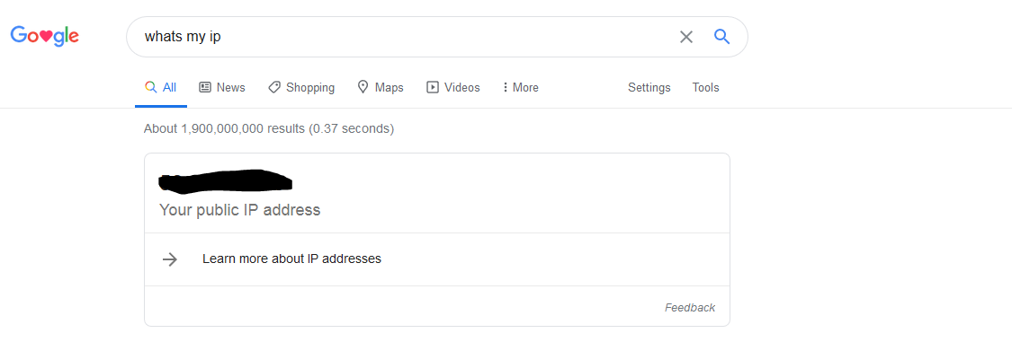
You will see your public IP address: xx.xx.xx.xxx
Copy this number

Prestashop Version 1.7.x
Now go back to back end of your prestashop. Go to Configure -> General
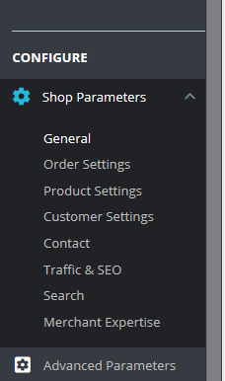
In the general section choose maintenance.
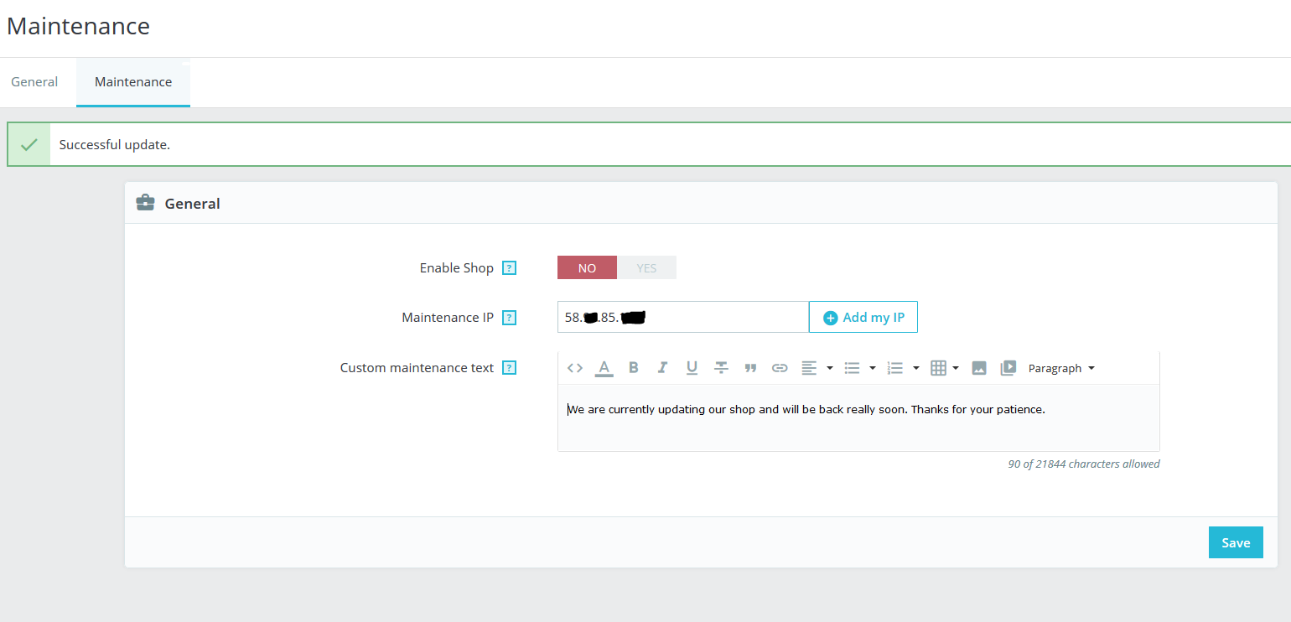
In here, to disable to the shop choose the option “No” in the section “Enable Shop”.
Put the IP address in section “Maintenance IP”
(Separate IP addresses with ',' (comma) character)
Click save.
Your shop will look like this in the public:
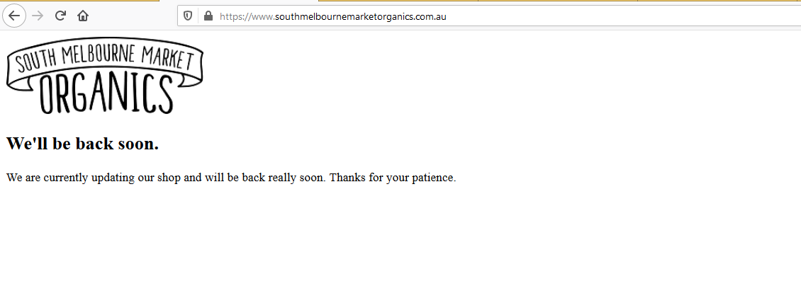
Reminder: Computers which has the same Public IP address above will still able to see the front-end.
To re-enable the website, simply choose “Yes” in the section “Enable Shop”.

For Prestashop Version 1.6.x
Go to Configure -> Preferences -> General
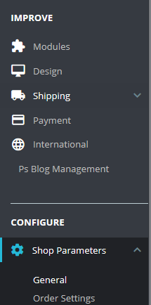
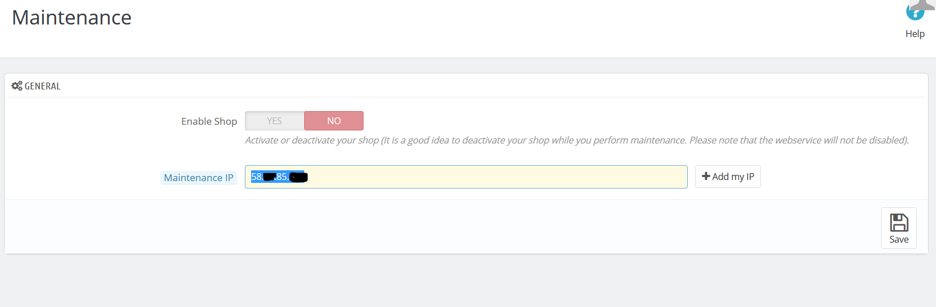
In here, to disable to the shop choose the option “No” in the section “Enable Shop”.
Put the IP address in section: “Maintenance IP”
Click save.
To re-enable the website, choose “Yes” in the section “Enable Shop”.

