Hi All,

We are pleased to introduce our new updated online Barcoding and Sales Analysis portal.

Each stallholder will receive their own PIN to enter products and view their sales online in real time. Please email info@market3196.com.au for your personal PIN.

We have purchased 2 new computers for stallholders to use at the Market to enter their products. A quick run through on how it works.
Add Products:

Log into the online portal with the following: https://portal.cloudposhq.com/ using the following details "label@market3196.com.au" and the password is "Market3196"
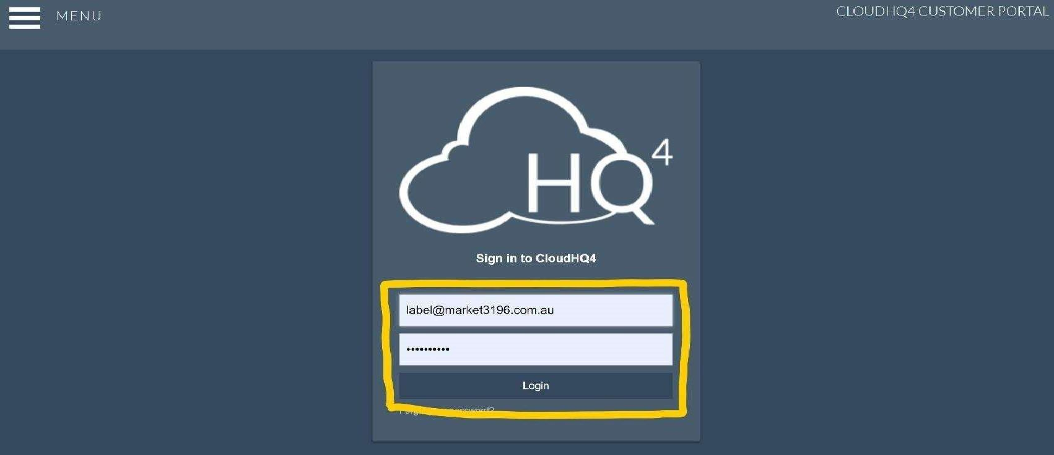

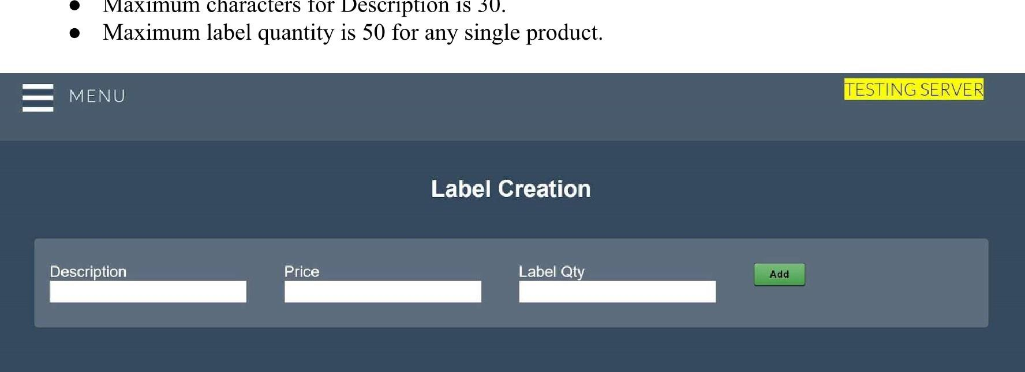On the opening screen enter your product Description, Price and Label quantity for that product.
Maximum characters for Description is 30.
Continue to add products required and they will appear as below.

Once you have entered all your products simply enter your PIN and the labels will be created.

If you make an error simply remove the item and re enter it.
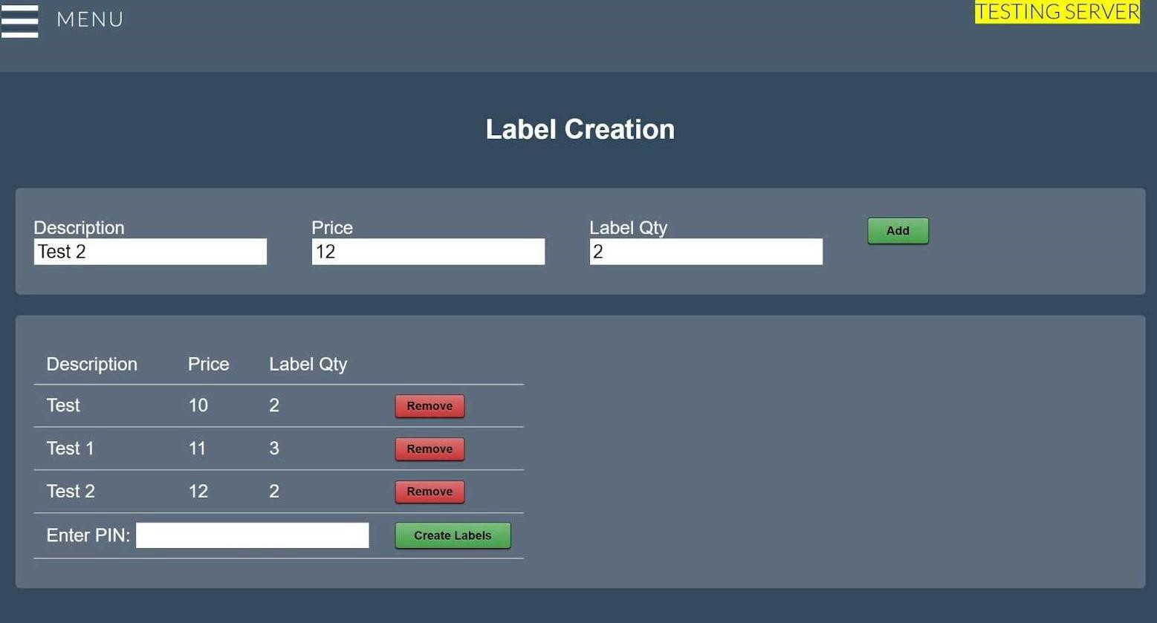 | ESTING

Email info@market3196.com.au for your personal PIN.

Once you have completed entering your products your barcode labels will be available the next business day. The barcodes labels can then be fixed to your products.

If you have any questions or need assistance please email info@market3196.com.au

Sales Analysis:

As described above log into https://portal.cloudposhq.com/

Go to "Menu" at the top left of the screen.

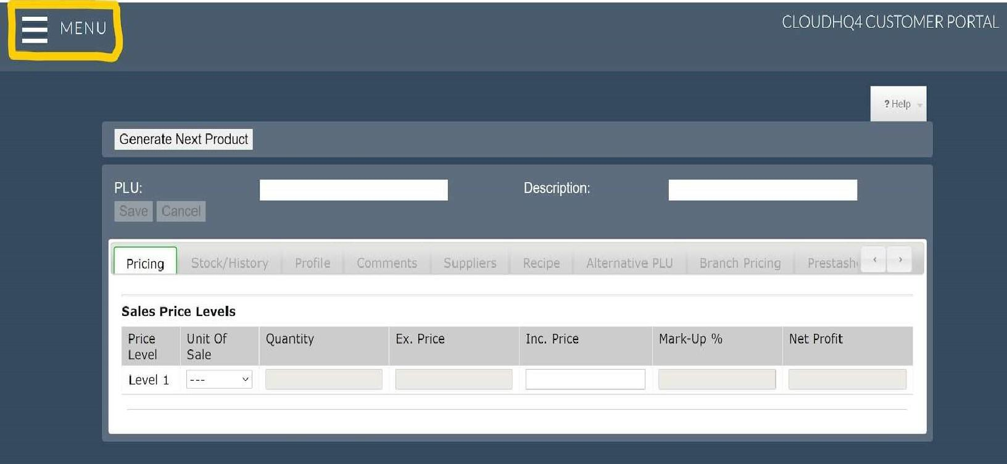

Go to "Sales Analysis"
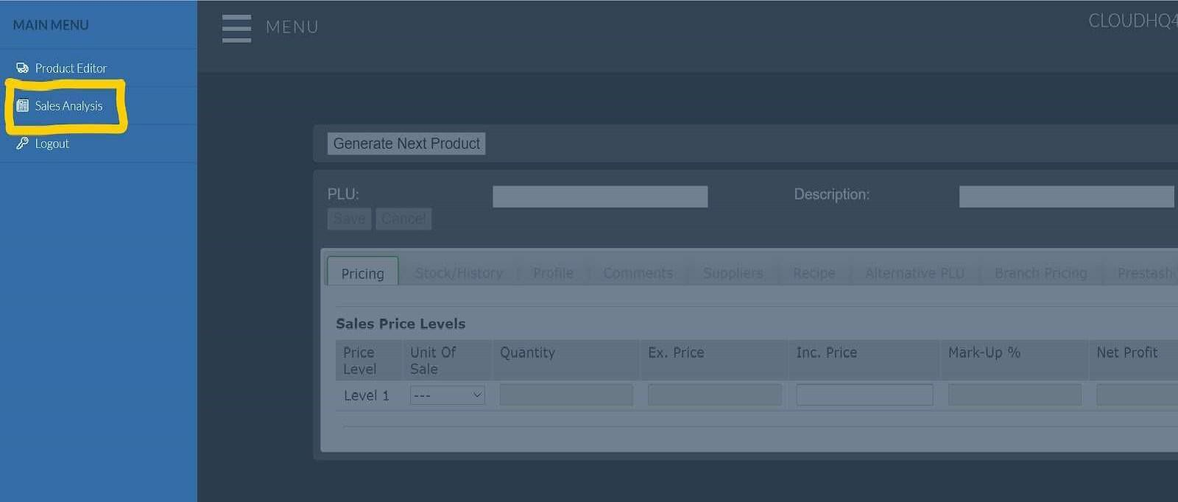

Click on the "From" and "To" to enter the date range.

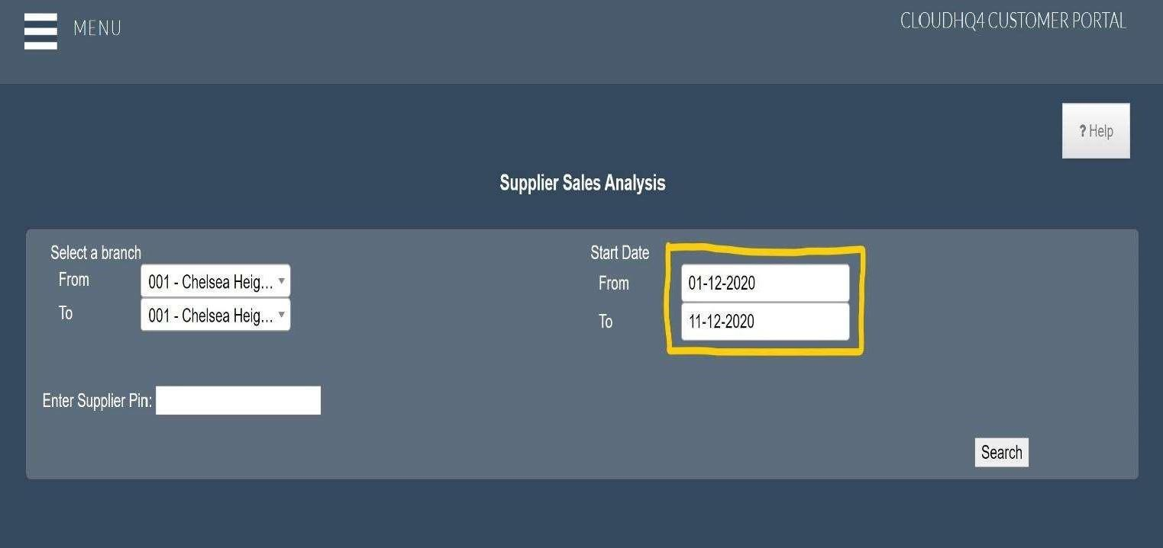

Enter your PIN and click "Search" to see the sales for the date range you have entered.
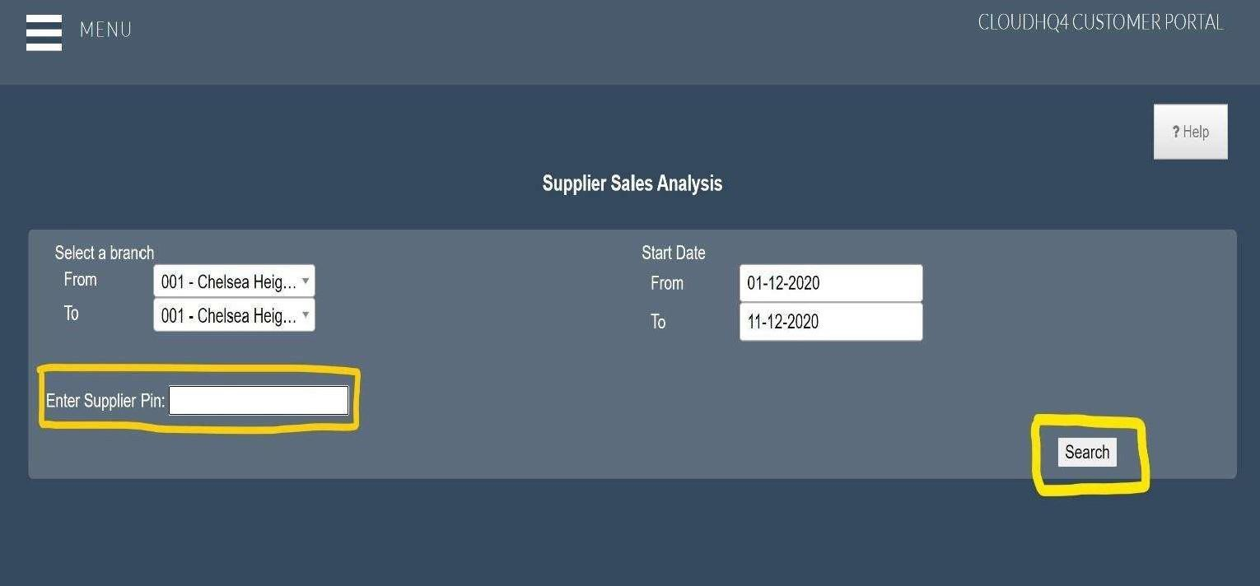

The sales list will detail the date, product description and price you used when you filled in the product entry for the barcode.

